**AI ASSISTED CODING **

***Lab 12: Algorithms with AI Assistance – Sorting, Searching, and  
Optimizing Algorithms***

Name:D.Nagamrutha

Roll no: 2503A51L06

**Task Description #1 (Sorting – Merge Sort Implementation)**• Task: Use AI to generate a Python program that implements the  
Merge Sort algorithm.  
**• Instructions:**  
o Prompt AI to create a function merge_sort(arr) that sorts a  
list in ascending order.  
o Ask AI to include time complexity and space complexity  
in the function docstring.  
o Verify the generated code with test cases.  
**• Expected Output:**  
o A functional Python script implementing Merge Sort with  
proper documentation.

**Prompt:**

Generate a python program to implement merge sort create function merge-sort(arr) that sorts a list in ascending order and include time and space complexity in the function docstring and check the generated code with test cases.

**Code Generated:**

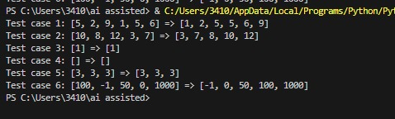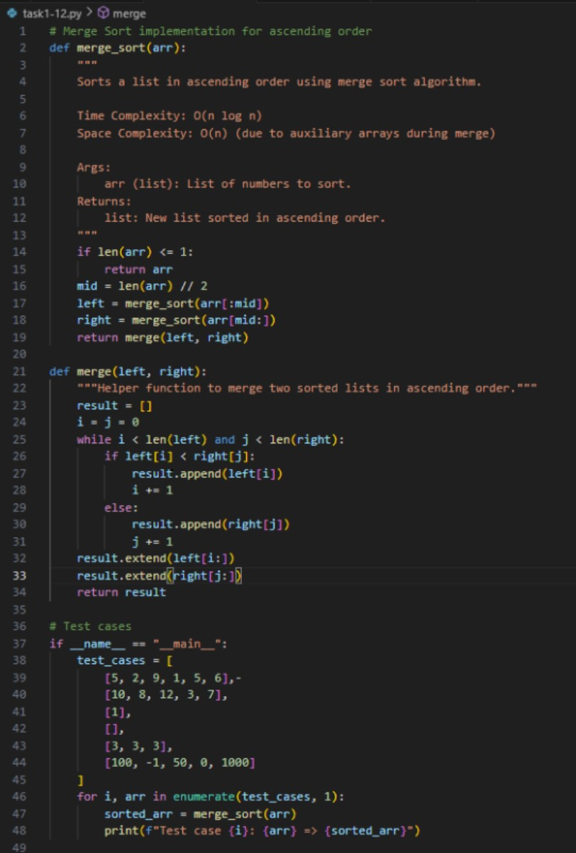**Output:**

**Observation:**

AI generated the merge_sort(arr) function using the divide-and-conquer strategy. It included a detailed docstring explaining time complexity (O(n log n)) and space complexity (O(n), which made the algorithm clearer. After running the AI-generated code with test cases, I observed that the list was sorted correctly. This showed me how AI can not only implement the algorithm but also document and verify it systematically.

**Task Description #2 (Searching – Binary Search with AI**  
Optimization)  
• Task: Use AI to create a binary search function that finds a target  
element in a sorted list.  
**• Instructions:**  
o Prompt AI to create a function binary_search(arr, target)  
returning the index of the target or -1 if not found.  
o Include docstrings explaining best, average, and worst-  
case complexities.  
o Test with various inputs.  
**• Expected Output:**  
o Python code implementing binary search with AI-  
generated comments and docstrings.

**Prompt:**

Create a function binary_search(arr, target) returning the index of the target or -1 if not found. Include docstrings explaining best, average, and worst- case complexities. Test with various inputs.

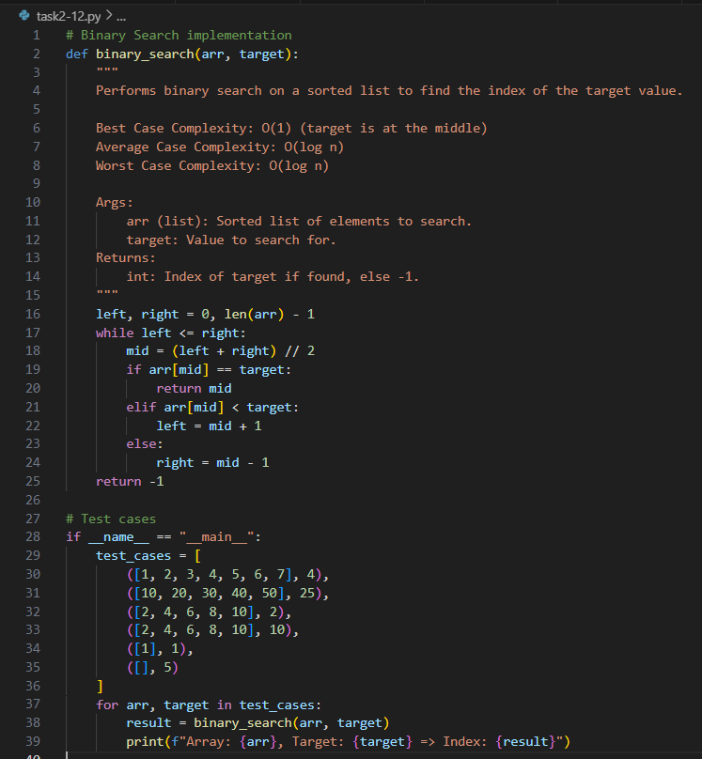**Code Generated:**

**Output:**

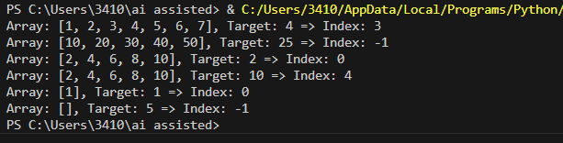

**Observation:**

AI implemented the binary_search(arr, target) function by repeatedly dividing the sorted list into halves. The function returned the correct index if the element was found, and -1 otherwise. The AI also explained best, average, and worst-case complexities directly in the docstring, which made it easier to connect theory with practice. Testing with multiple inputs confirmed the accuracy, and I learned how AI-generated code can be both optimized and self-explanatory.

**Task Description #3 (Real-Time Application – Inventory  
Management System)**  
• Scenario: A retail store’s inventory system contains thousands of  
products, each with attributes like product ID, name, price, and  
stock quantity. Store staff need to:  
1. Quickly search for a product by ID or name.  
2. Sort products by price or quantity for stock analysis.  
**• Task:**  
o Use AI to suggest the most efficient search and sort

algorithms for this use case.  
o Implement the recommended algorithms in Python.  
o Justify the choice based on dataset size, update frequency,  
and performance requirements.  
**• Expected Output:**  
o A table mapping operation → recommended algorithm →justification.  
o Working Python functions for searching and sorting the  
inventory.

**Prompt:**

Generate a code that suggests most efficient search and sort algorithms and implements the recommended algorithms and justify the choice and sort products by price or stock. Let user provide inputs.

**Code Generated:**

**Output:**

**Observation:**

For the inventory system scenario, AI suggested using Binary Search for quick product lookups and efficient sorting algorithms (Merge Sort/Quick Sort) for arranging products by price or quantity. It justified these choices based on dataset size and performance requirements. The AI also provided a Python implementation that allowed searching by ID/name and sorting using options. Through this, I observed how AI applies theoretical algorithms to solve real-world problems, while also justifying the decisions with clear reasoning.